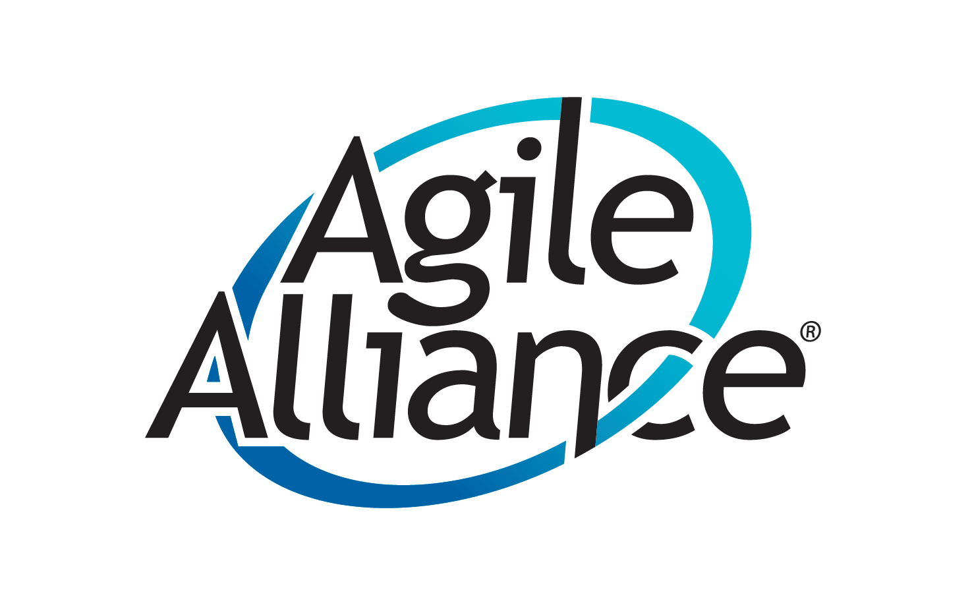 | Agile Alliance Payments  Payment Method Option Form

Contact Details [Please fill in ALL fields]
Name: |  | Email address:
Address: |  | Phone Number:
 |  | Amount: _____

Your payment method choice [choose one, then fill in the relevant section below]:
ACH (US BANK ONLY)  Complete section 1 | Zelle (US only)  Email or mobile#:  _______________ | Physical Bank  Check (US only)  Payable to (if different than  Name):  _________________ | Wire Transfer  (Outside US)  Complete section 2

Please select a payment method above, then fill in only (1) section below.
Section 1: ACH [A copy of a VOID check or fill in the information below]
Name on Account:
Routing#:
Account#:

Section 2: International Wire Transfer details
Country: |  | Local Currency*:
Bank name: |  | Swift  code/BIC:
Name on  Account: |  | IBAN/Bank account number:
*There is a $35 fee for USD.

