The Title of Your Experience Report
Author’s name, Your company
Second Author’s Name, Your company
This is the abstract. It is a 2 to 3-sentence overview of your experience report. Explain the gist of your experience in one sentence and mention one or two key findings or topics covered.

INTRODUCTION
There are several sections to your paper. The first section introduces your experience and mentions some key aspects that make your experience unique or interesting. In it, try to hook your audience and get them interested in reading the rest of your paper.
In an experience report, you, the author, are very much part of the story. While it is always good to present evidence in your report, what makes an experience report unique and compelling is that it is also a personal story. One powerful way that people learn is by relating to the dilemmas, thought processes and successes and failures of others. So be sure to include something about yourself in this story.

Background
After the introduction, give more background or lay out some challenges you faced. It is up to you. You can introduce yourself and briefly describe your company or project or team. Readers like to know who you are. Enable the reader to put themselves into your shoes (i.e. - the author’s place) and understand how you approached solving the problems with which you were confronted.

Your Story
An experience report usually has at least three sections. Beginnings, next, then, and then…Each section should tell a coherent part of you story. Sections, if long enough, may have sub-sections.
It is important that readers understand the timeline (when things started, what happened next, and then) and scope of your experience (how many people, teams, parts of the organization…).
Not all experience reports follow the same format. That’s fine. Feel free to choose a different way to organize your experience than we show here. For example, you might have several activities you did (each in its own major section). Or, you may want to write about your experience in one section and wrap up with a WHAT’S NEXT section.

Problems
Despite …. We had these problems.

What you did
Next…

Results
And then…Now that you did x, y, and z, what happened? Explain how things changed. Were they better or worse? Were there unintended consequences? What did you learn? You also might explain how your learning fed into choosing and/or addressing your next problem.
Sometimes authors include charts and information graphics from their projects (see Figure 1). These emphasize important practices or findings. Be sure they are legible. Don’t just include them as filler.
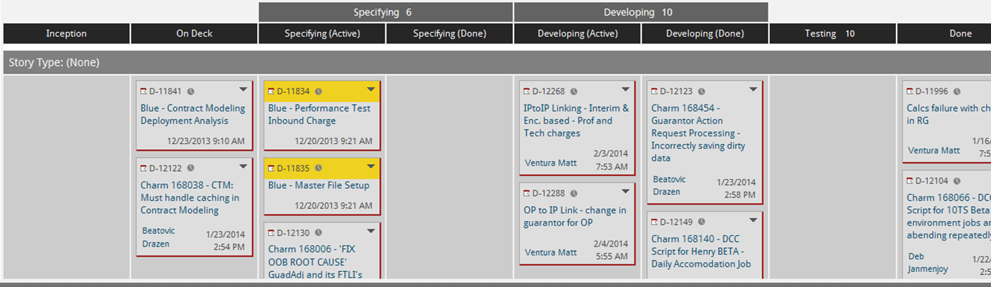
Figure 1. Example Kanban Board
You can also include photos, as long as they contribute to your story.

What We Learned
After you tell what you did, you might want to reflect more about what you learned.
Were there things you wished you had done differently? What key experiences particularly standout? How did your thoughts, practices, or values change?

Acknowledgements
This optional last section is where you sincerely thank others. We encourage you to acknowledge those who helped you along the way. Acknowledge co-workers or colleagues or people who reviewed your writing. Thank your boss or your company for allowing you to do what you did. Last, but certainly not least, thank your shepherd. This paper would not have come together without your shepherd’s keen insights, questions, and edits: Thanks, Shepherd, we couldn’t have done it without you!
REFERENCES
Here are three sample references. Usually an experience report doesn’t have lots of references to technical publications. But you may want to point out some. You should mention a reference in your paper, for example, (Goldratt) then have an entry in the reference section for each reference. You can reference blogs or papers or books.
Goldratt, Eliyahu M. “The Goal, A Process of Ongoing Improvement” North River Press, 3rd revised edition, 2004
Little, John D C “Little’s Law as Viewed on its 50th Anniversary” Operations Research, Vol. 59, No. 3, May–June 2011, pp. 536–549)
Vacanti, Daniel, Corporate Kanban blog, http://www.corporatekanban.com

Author's address: Name, Physical address; email: yourEmail@xyz.com Second author's address: Name, Physical address; email: yourEmail@xyz.com Each author should list his or her name and contact information. Others may want to ask you questions or contact you for more details. Copyright 2014 is held by the author(s).

